Creating and working with delta lake table
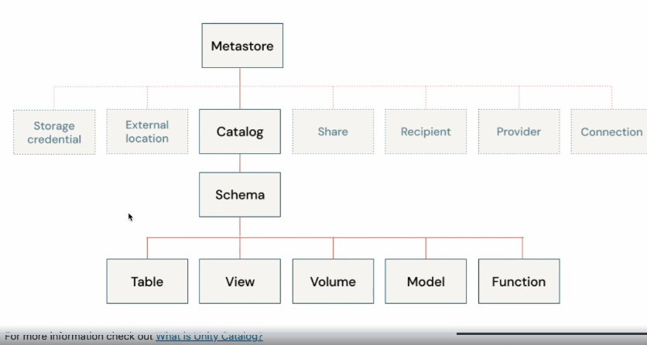

USE CTALOGE ${module_cataloge};
USE SCHEMA IDENTIFIER{ :my_schema};
- View your set cataloge schema
SELECT
Current_cataloge() as current_cataloge;
Current_schema() as current_schema;
Use DESCRIBE SCHEMA EXTENDED statement to display the metadata and properties of the schema.
DECRIBE SCHEMA EXTENDED IDENTIFIER( :my_schema);
Use show tables statement to display the available tables in the schema.
SHOW TABLES;
Use show volumes statement to list all of the volumes available in schema. Volumes are unity catalog objects representing a logical volume of storage in a cloud objects storage location. Volume provide capabilities for accessing, storing, governing and organizing files. While tables provide governance over tabular datasets, volume add governance over non-tabular datasets. You can use volumes to store and access files in any format, including structured, semi and unstructured data
SHOW VOLUMES;
LIST ‘/volume/${module_cataloge}/${my_schema}/myfiles’;
Create a delta table from csv file. all the tables on databricks are delta lake by default.
SELECT * from csv.’ / volume/${module_cataloge}/${my_schema}/myfiles /employee.csv’);
It shows the data and the columns are in the row as well.
SELECT * from read_files(’ / volume/${module_cataloge}/${my_schema}/myfiles /employee.csv’,
Format => ‘csv’,
Header => true,
Infer schema => true);
There is a rescue column to provide by default to rescue data that doesn’t match any schema.
%SQL
- Drop the table if it is already exists for demonstarion purpose
DROP TABLE IF EXISTES current employees:
- Create a delta table using csv file select from file regarding the created table(CTAS)
CREATE TABLE current_employees USING DELTA
AS
SELECTED ID,FIRSTNAME,COUNTRY,ROLE
FROM read_files( ’ / volume/${module_cataloge}/${my_schema}/myfiles /employee.csv’,)
Format => ‘csv’,
Header => true,
Inferschema => true);
Infer schema helps to data to infer the schema and type of column
DESCIBE DETAILS current_employee;
Additional information about delta table.
The version columns display the table is on version 0.
The timestamp indicates when table is created.
The operation shows what operation was performed.
DESCIBE EXTENDED current_employee;
Display the results of metadata of the table.
The insert, update, delete transaction on DelatLake:
SELECT * from current_employee;
- Insert 2 employees into the table
INSERT INTO current_employee VALUES (ID,’NAME’,’COUNTRY’,’ROLE’);
- Update a record in the table
UPDATE current_empolyee
SET ROLE = ‘JUNIOR ENGINEER’
WHERE ID = 1111;
- Delete a record in the table
DELETE FROM current_employee
WHERE ID = 3333;
Each operation that modifies a Delta Lake table creates a new table version.View the history of the table. The table has 4 versions 0 through 4:
Version 0: the orginal table that was created.
Version 1: contains the write opertation that inserted 2 new employees.
Version 2:contains update
Version 3: contains delete operation
Version 4: contains the optimize operation on the table. (it has done by default)
Use Time Travel to read previous versions of the delta tables
you can use the history information to audit operations, rollback a table or query a table at aspecific point in the time using time travel.(versionig related to time travel in json and metadata and log file saved beside the parquet file for data)
By default if you selelct * from current_empolyees orderby ID it show the last version.
Use time travel to use the view the table to the DELETE operation. Notice that the table shows 6 rows before any records deleted.
Time travel takes advantage of the power of Delta Lake transaction log to access data that is no longer in the table.
Drop Delta table
DROP TABLE IF EXISTES current_employee;

- Recourse: data bricks academy

